CS 665 Introduction to Database Systems

Spring 2020 Project Phase-I

Student: Kyle Lanier

1. Detailed description of the database application.

* **Name:** WSU Applied Learning Database
* **Purpose:** To manage WSU applied learning contracts within the business community
* **Entity Descriptions:**
  + **Students:** Any current WSU student in need of a co-op or internship. Attributes include:
    - studentId: Primary Key that uniquely identifies a WSU student.
    - studentName: The name of the student.
    - tenure: The grade level of the student (freshman, sophomore, junior, senior, graduate).
    - graduationDate: The expected date of graduation in which the individual is eligible for hire.
    - major.
  + **SkillSets:** A skill-set contains one or many skills which are defined by the requirements to satisfy a unique project, such as a co-op or internship. Attributes include:
    - skillSetId: Primary Key that uniquely identifies a list of skills for a project.
    - date: the date the skillset was created.
  + **Skills:** A skill is an ability to do something well with respect to satisfying a technical or professional capability within the scope of a project, such as a co-op or internship. Attributes include:
    - skillName: Primary Key that names a unique skill such as troubleshooting, python, powerBI, ect.
    - skillLevel: A level of proficiency or experience regarding a unique skill such as beginner, intermediate, proficient.
    - description: A meaningful description to elaborate a skill.
  + **Projects**: A project applies one or more students, each with a common skill set, towards a co-op or internship. Attributes include:
    - projectId: Primary Key that uniquely defines a co-op or internship.
    - type: The type of project such as technical support, application development, data analytics, ect.
    - numStudents: The number of students required for a project.
    - isRemote: Boolean that flags a project as being remote or onsite.
  + **Contracts**: A contract defines a cost as well as time constraints with respect to the business community hiring WSU students for an applied learning project. Attributes include:
    - contractId: Primary Key that uniquely identifies the scope of an applied learning project.
    - companyManager: The manager at the company responsible for managing the WSU students.
    - studentWage: The price to be paid per WSU student working hour.
    - startDate: The beginning date for an applied learning project.
    - endDate: The ending date for an applied learning project.
    - cost: The total project cost WSU charges for leveraging student talent.
  + **Companies**: An organization within the business community in need of cost-effective labor or a new talent pool to hire from. Attributes include:
    - companyName: Primary Key that uniquely identifies a business.
    - abbreviation: The abbreviated version of the company name.
  + **Locations**: The physical geographical location, address, of a student or business. Attributes include:
    - locationId: Primary Key that uniquely identifies a physical address.
    - street: The street name, unit, apt, suite information of the address.
    - city: The city location of the address.
    - state: The state location of the address.
    - zipcode: The zip-code of the address.
* Relationship Descriptions:
  + **Located**: Relates a company to an address location.
  + **Grants**: Relates a company to one or more contracts.
  + **Defines**: Relates a unique contract to a unique WSU applied learning project.
  + **Requires**: Relates an applied learning project to a required (and unique) set of skills.
  + **Contains**: Relates a unique skillSetId to a list of skills.
  + **Matches**: Relates a student to a unique skillSetId.
  + **Near**: Relates a student to a business location
* Extracted Information:
  + What companies are interested in hiring WSU students and what skills are in demand?
  + Which students have in-demand skills and are near the business?
  + What positions, and skills, do we need to train backfill to prepare for student graduation?
* Modification Updates:
  + Adding, modifying, or removing any record from the defined entity descriptions above.

1. A detailed E/R diagram which includes accurate relationships and use of arrows.

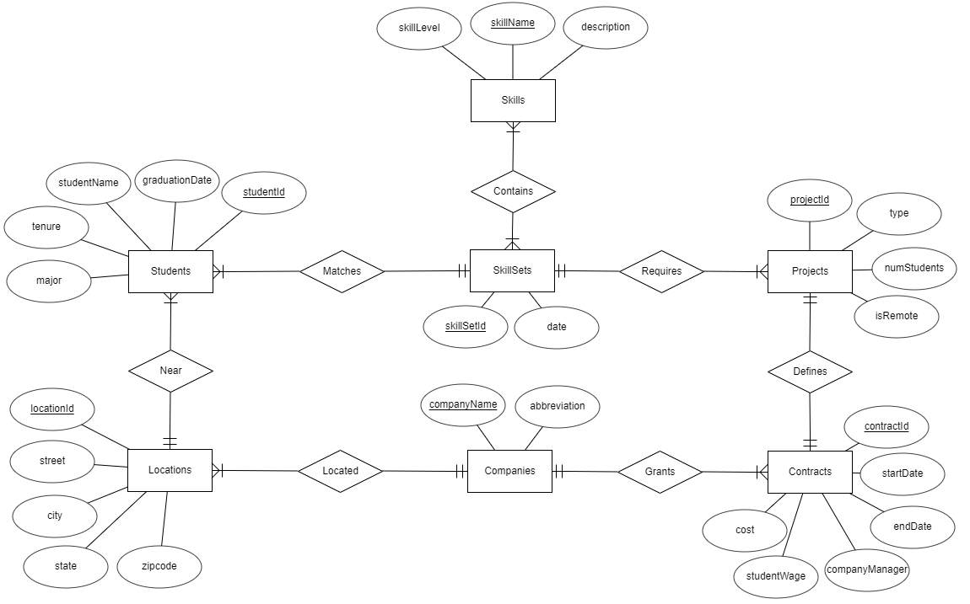

1. The relational schemas for the entity sets with primary keys underlined and foreign keys identified (in italics or enclosed within double quotes).

* Students(studentId, studentName, major, tenure, graduationDate, *skillSetId, locationId*)
* SkillSets(skillSetId, date)
* Skills(skillName, skillLevel, description)
* Projects(projectId, type, numStudents, isRemote, *skillSetId*)
* Contracts(*companyName*, contractId, startDate, endDate, companyManager, studentWage, cost, *projectId*)
* Companies(companyName, abbreviation)
* Locations(locationId, street, city, state, zipcode, *companyName*)
* Matches: this is a many to one relationship, so we merge the skillSetId into the Students schema.
* Requires: this is a many to one relationship, so we merge the skillSetId into the Projects schema.
* Defines: this is a one to one relationship, so we merge the projectId onto the Contracts schema.
* Grants: this is a many to one relationship, so we merge companyName into the Contracts schema.
* Located: this is a many to one relationship, so we merge the companyName into the Locations schema.
* Near: this is a many to one relationship, so we merge the locationId into the Students schema.